INTERVIEW QUESTION BANK
@CREATIVITY THINK (9483175986/7019689991)

ABSTRACT:
Interview Question Bank is a dynamic web-based application designed to help users prepare for interviews through topic-wise, company-wise, and difficulty-based curated questions. The system provides a structured environment for learning, practicing, and tracking performance using bookmarks, personal notes, and practice modes. A powerful user dashboard displays analytics such as attempted questions, correctness percentage, and weak topics. Administrators manage questions, topics, companies, and overall user usage statistics through a dedicated dashboard. Built with Django REST Framework and React, the platform ensures seamless, fast, and interactive usage for students, job seekers, and professionals preparing for coding or non-coding interviews..

INTRODUCTION OF THE PROJECT:
In today’s competitive job landscape, systematic interview preparation is essential. Scattered resources, lack of organization, and absence of structured practice make preparation inefficient. Interview Question Bank solves these challenges by offering a centralized platform where users can browse company-wise and topic-wise interview questions, attempt practice sessions, create personal notes, and bookmark important questions.
The system offers detailed analytics that help users identify strengths and weaknesses, while administrators can maintain the question database and analyze user engagement through visual dashboards..

PROJECT OBJECTIVES:

• Provide topic-wise, company-wise, and difficulty-based question browsing
• Allow users to maintain personal notes for questions
• Enable bookmarking of important questions
• Provide practice mode with random or filtered question attempts
• Offer user analytics including attempted questions, accuracy, weak topics
• Allow admins to manage questions, topics, difficulty levels, and companies
• Provide admin dashboard showing user activity, most viewed topics, difficulty stats
• Ensure fast and interactive UI using React and REST APIs

PROBLEM OF THE STATEMENT:
Interview preparation resources are often scattered, unorganized, and lack personalization. Users struggle to track progress, bookmark questions, or maintain structured notes. There is also no centralized system for topic-wise and company-specific preparation.
Interview Question Bank addresses these problems by providing a single, structured platform where users can study, practice, and track performance while admins maintain updated question sets..

MOTIVATION OF THE PROJECT:
• To simplify interview preparation through structured question organization
• To help students identify weak areas using dashboards and analytics
• To provide a practice mode mimicking real interview patterns
• To reduce dependency on multiple platforms or offline notes
• To enable admins to maintain a high-quality question repository
• To support placement training, job preparation, and professional upskilling

BLOCK DAIGRAM OF PROJECT:

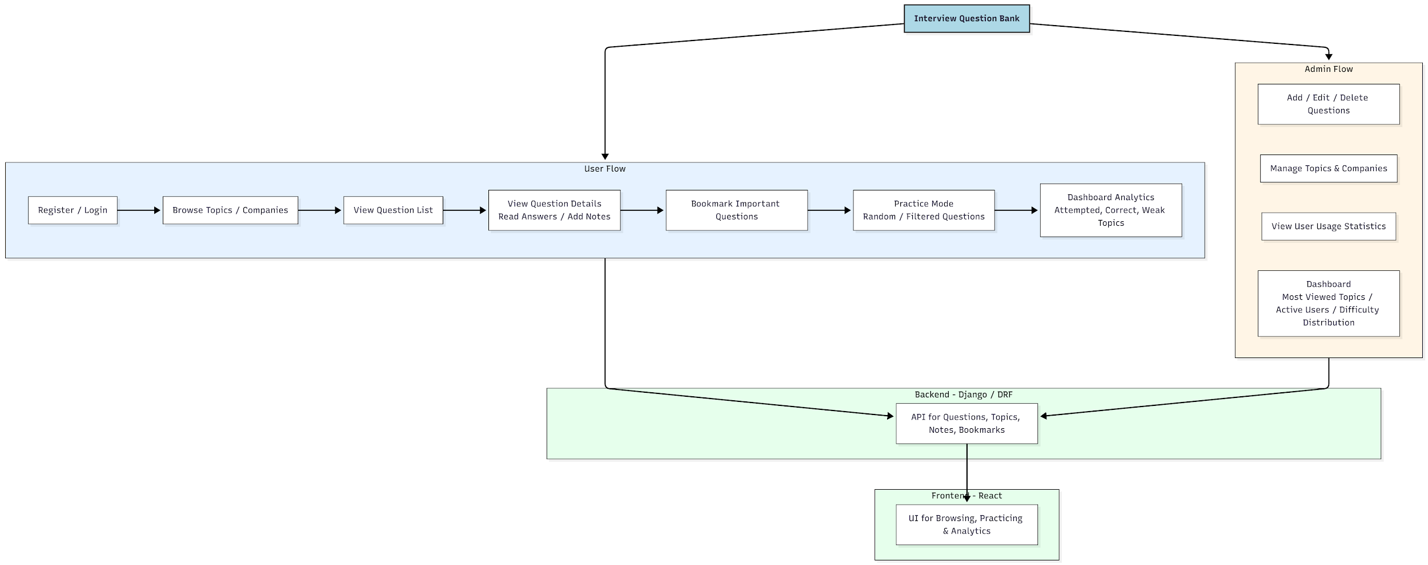

WORKING OF THE PROJECT:
Users begin by registering and logging into the platform. They can browse questions based on topics, companies, or difficulty levels. Each question page shows details, answers, and the ability to add personal notes. Users may bookmark important questions for future review.
The practice mode provides randomized or filtered question sets, helping users simulate exam/interview patterns. Analytics generated in the user dashboard show their accuracy, total attempts, and weak topics.
Administrators use a dedicated dashboard to add or update questions, manage topics and companies, and monitor user activity. The system is powered by Django REST Framework APIs handled on the frontend by React for seamless interactivity..

SOFTWARE REQUIREMENT:
- Backend:
  - Python 3.x
  - Django
  - Django REST Framework
  - SQLite/PostgreSQL
- Frontend:
  - Node.js and npm
  - React.js
  - Axios
- Development Tools:
  - Visual Studio Code
  - Postman (for testing APIs)
  - Git/GitHub (for version control)
- Server/Deployment (Optional):
  - Gunicorn, Nginx, or Heroku/AWS for hosting

ADVANTAGES OF THE PROJECT:

• Centralized platform for structured interview preparation
• Topic-wise, company-specific, and difficulty-based filtering
• Practice mode enhances retention and confidence
• Bookmark and notes feature for personalized learning
• Visual analytics show performance insights
• Admins can update question banks anytime
• Fully responsive and fast interface
• Suitable for college students and job seekers

APPLICATIONS OF THE PROJECT:
• Placement training platforms
• Personal interview preparation
• Coaching and training institutes
• Company HR/training departments
• Online learning platforms
• Colleges conducting placement preparation programs

REFERENCES:

- Django REST Framework Documentation — Django Software Foundation. Django Documentation. Available: https://docs.djangoproject.com/
- Django REST Framework. DRF Documentation. Available: https://www.django-rest-framework.org/
- React. React Official Documentation. Available: https://reactjs.org/docs/getting-started.html
- Redux. Redux Documentation. Available: https://redux.js.org/introduction/getting-started
- PostgreSQL Global Development Group. PostgreSQL Documentation. Available: https://www.postgresql.org/docs/
- MySQL. MySQL Reference Manual. Available: https://dev.mysql.com/doc/
- Git. Git Documentation. Available: https://git-scm.com/doc
- Node.js. Node.js Documentation. Available: https://nodejs.org/en/docs/
- Axios. Axios Documentation. Available: https://axios-http.com/docs/intro
- Socket.io Documentation – https://socket.io/docs/

